**Milestone #4 - MS4 (Queries)**

In our project we followed a few steps to carry out our work in a processed plan.

Firstly for the milestone #1 We identified the requirements that we needed to complete the project and then we chose a dataset to fulfill all the requirements specified to give the potential solutions for our upcoming challenges. We planned to take covid dataset from the available resources.

In milestone #2, According to the specifications provided we have done our research to get the most possible data to give our project a fullest look. After collecting all the data we provided the queries which can be extracted from the obtained data.

In milestone #3, we have created a data design which is a prototype for the model that we are going to build. We queried DDL commands and got a picture on what we are going to work on further. We are working on cleaning the data as per the requirement. Since mining and cleaning is done, In next steps we just have to transform data i.e., do data transmission as per the requirement. In data transmission we will evaluate and do the necessary improvements required for successful completion of our project.

After all this data processing we will perform our SQL queries to provide the final report to our project.

We have created all the table using the DDL commands we provided in our #MS3 and inserted all the collected CSV data into the created tables using the above query for respective tables.

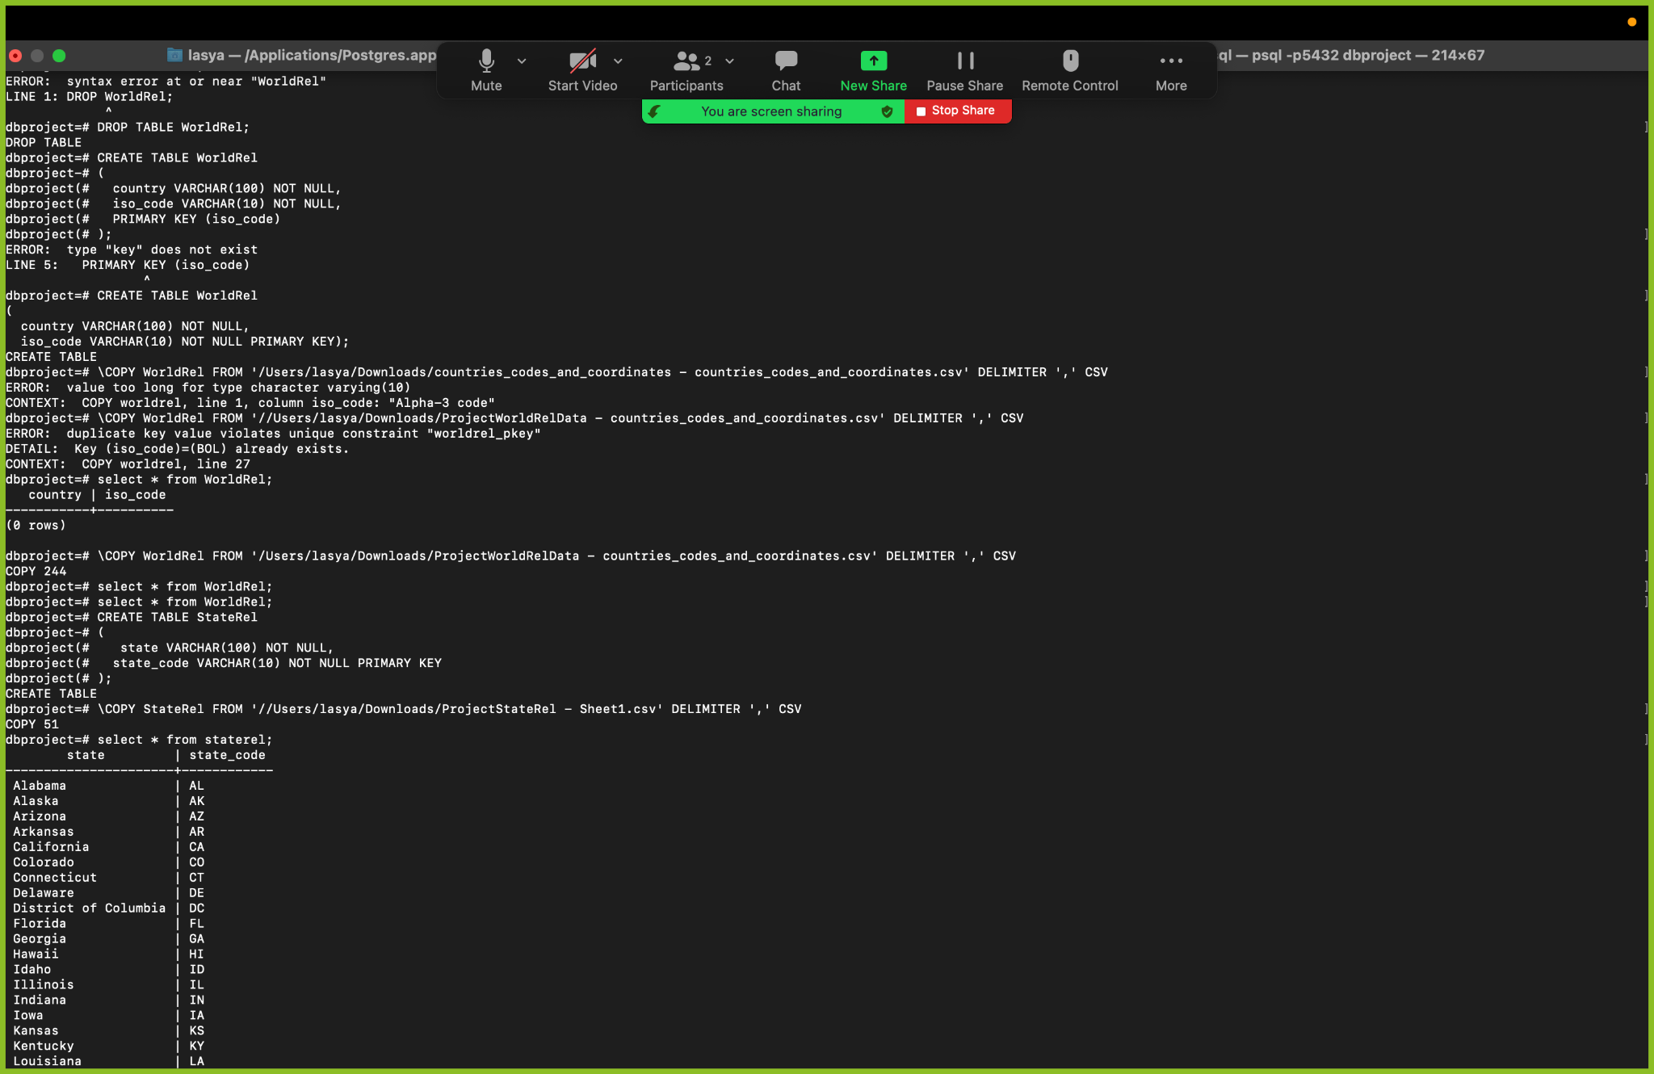

1. Write a query that returns cases and deaths with their respective dates of United States

**SELECT cases, deaths, date FROM worldwide_cases where country = ‘United States’;**

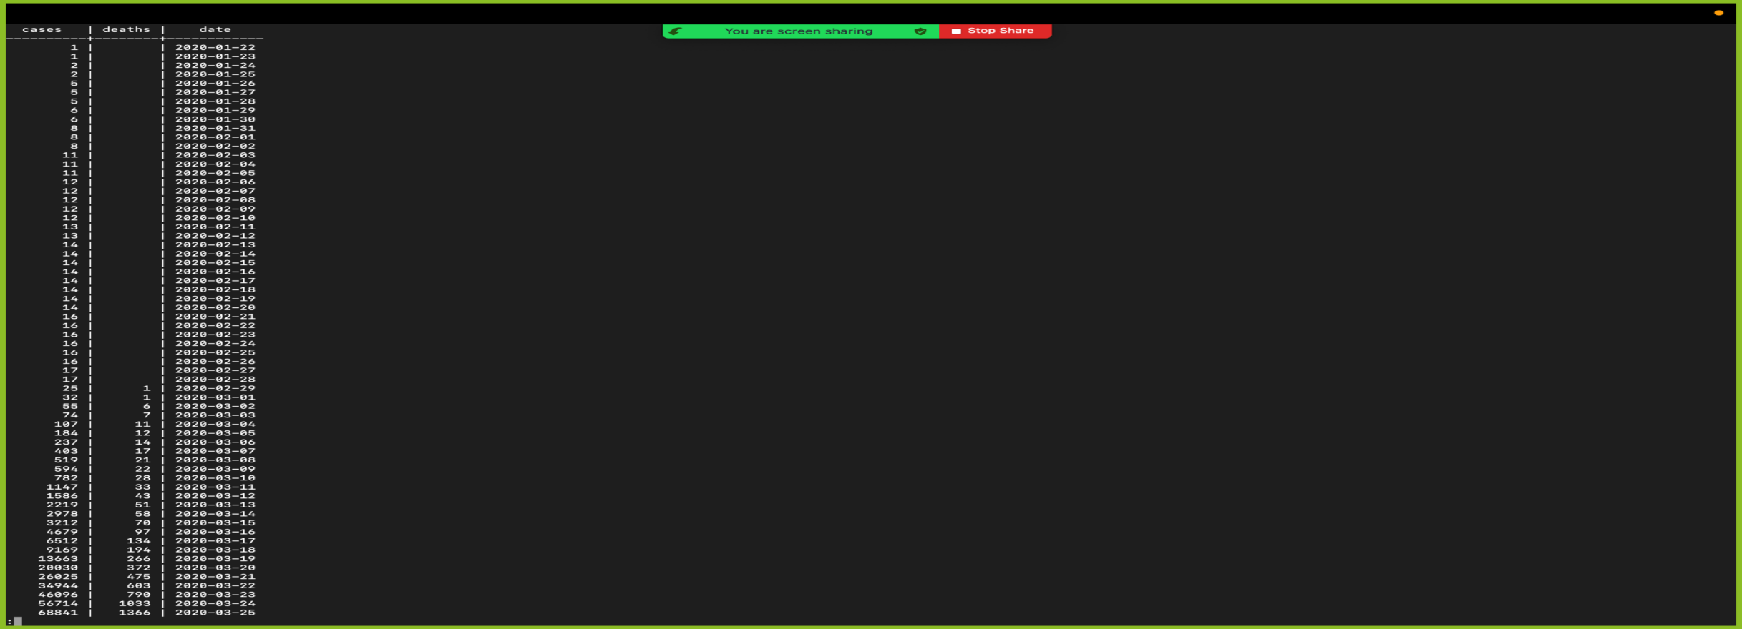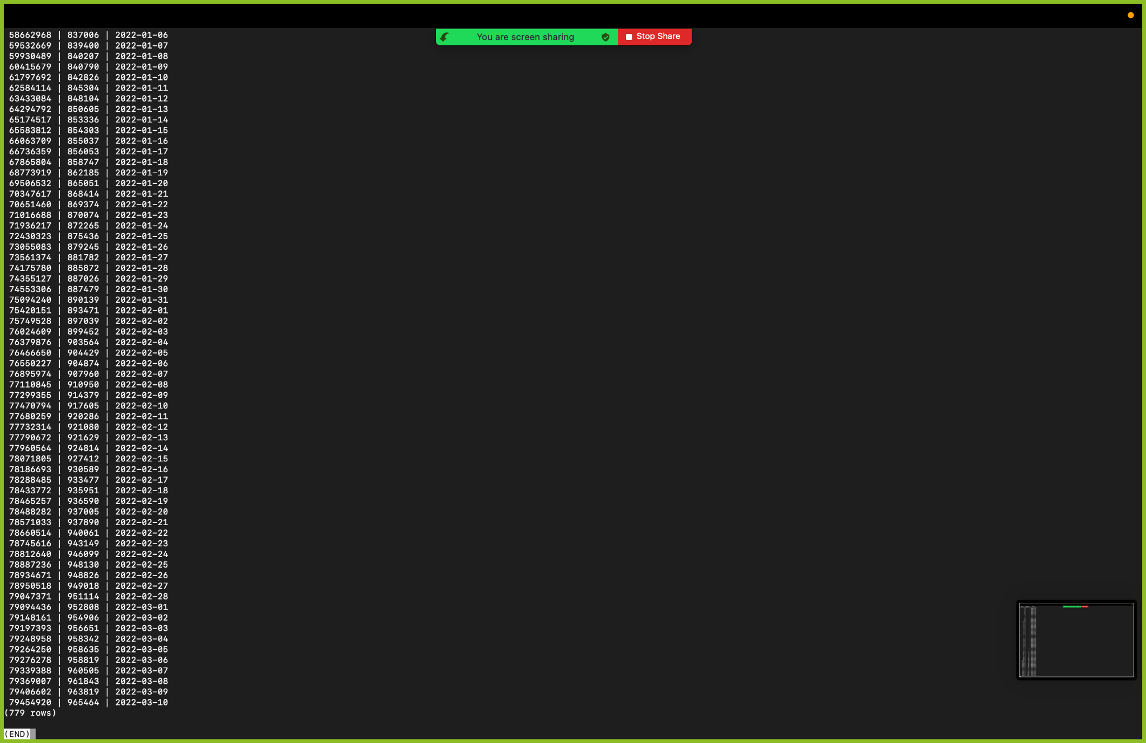

1. Write a query that returns total number of cases and deaths worldwide excluding United States

**SELECT COUNT(cases), COUNT(deaths) FROM Worldwide_Cases Where country NOT IN(‘USA’);**

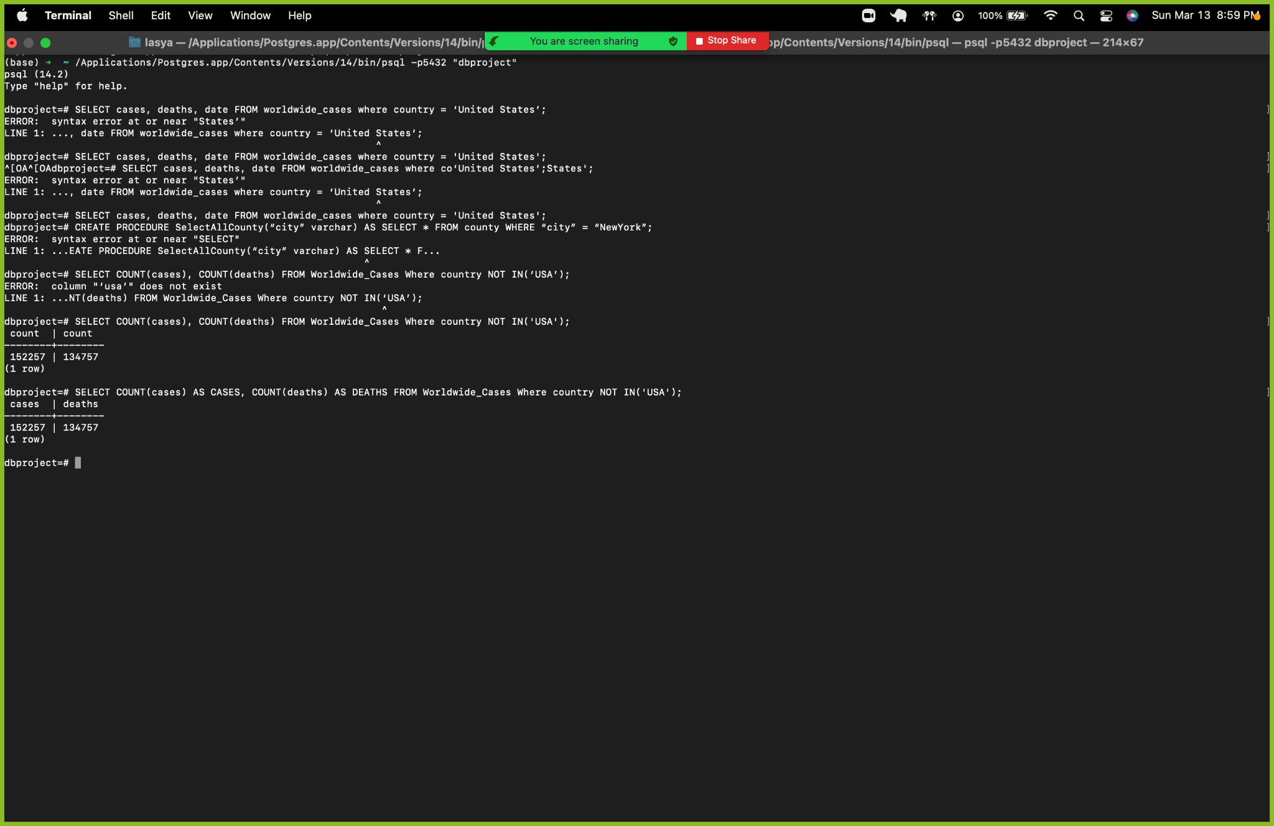

1. Write a query that returns the avg number of cases and deaths worldwide excluding the United States.

**SELECT AVG(cases) as cases, AVG(deaths) as deaths FROM Worldwide_Cases WHERE country != ‘United States’;**

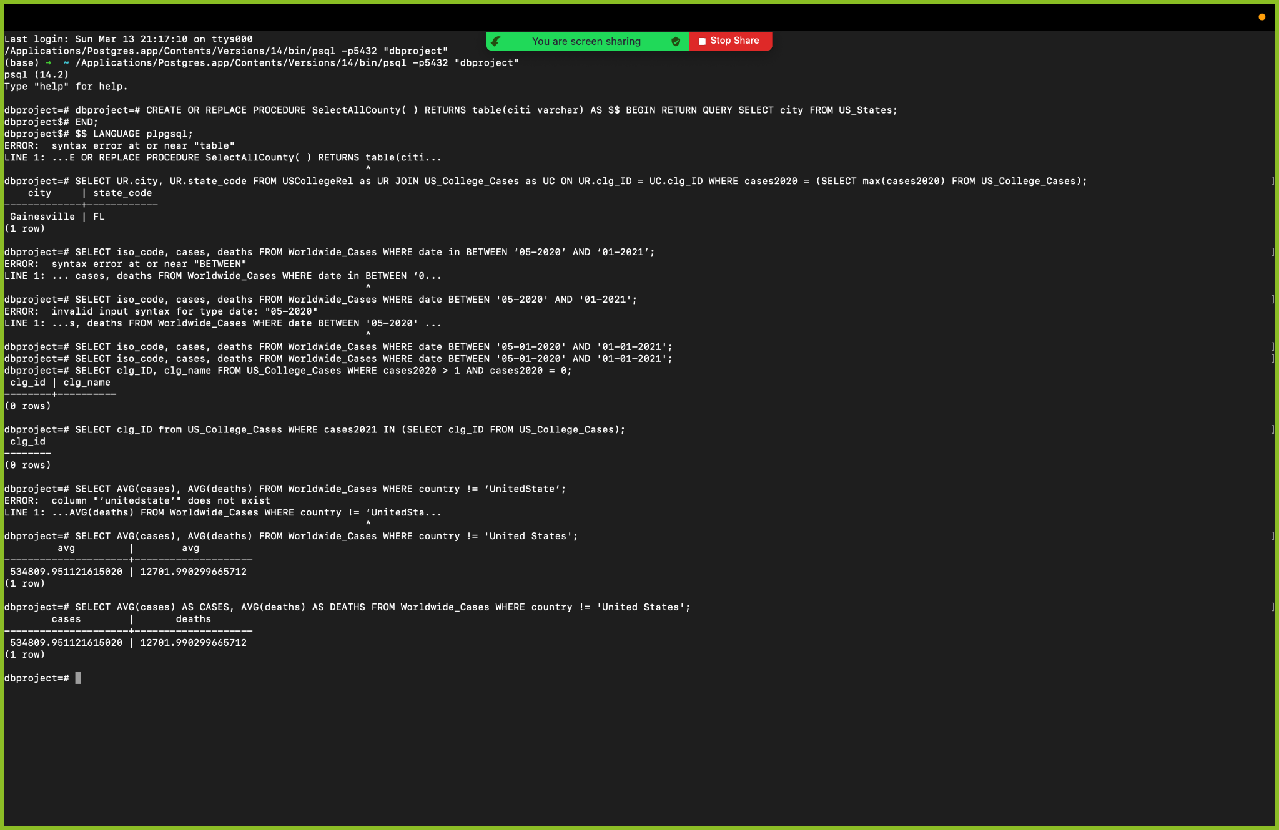

1. Write a query to add records fetched from worldwide cases into the United_States_covid_record table.

**INSERT INTO United_States_covid_record SELECT * FROM Worldwide_Cases WHERE iso_code = ‘USA’;**

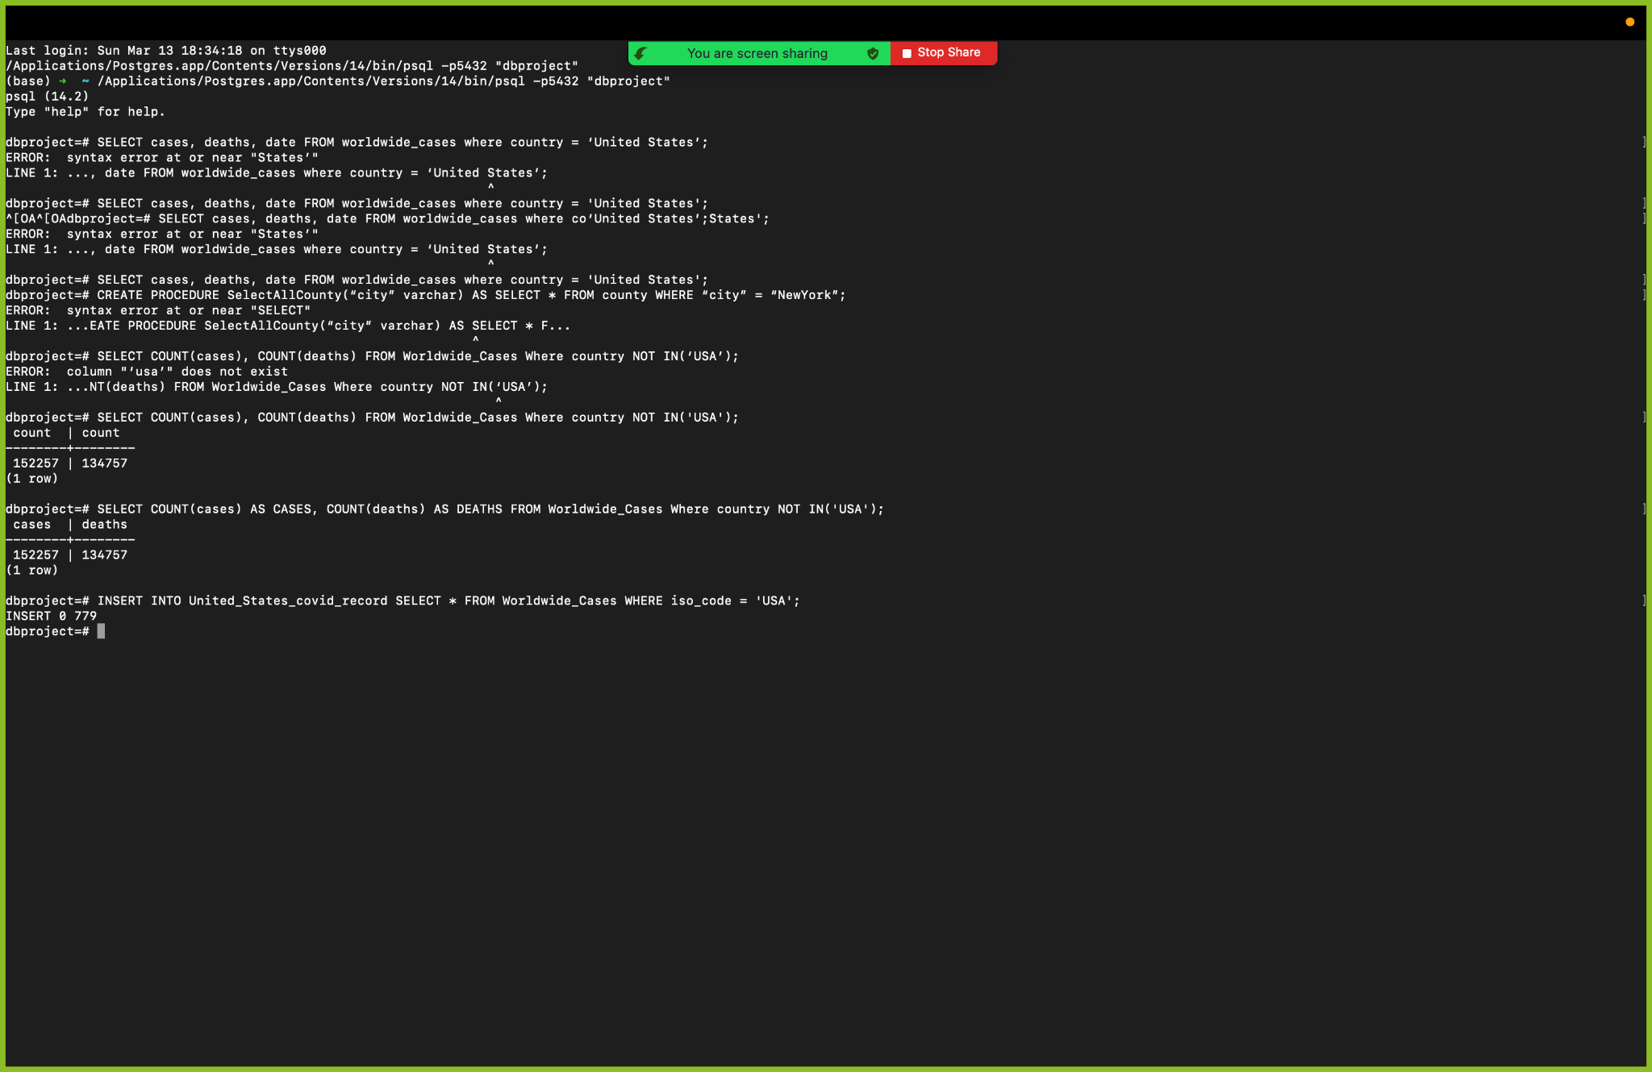

1. Write a query that returns total number of cases and deaths in United States

**SELECT iso_code, SUM(cases + deaths) as total FROM Worldwide_Cases WHERE iso_code = ‘USA’ Group By iso_code;**

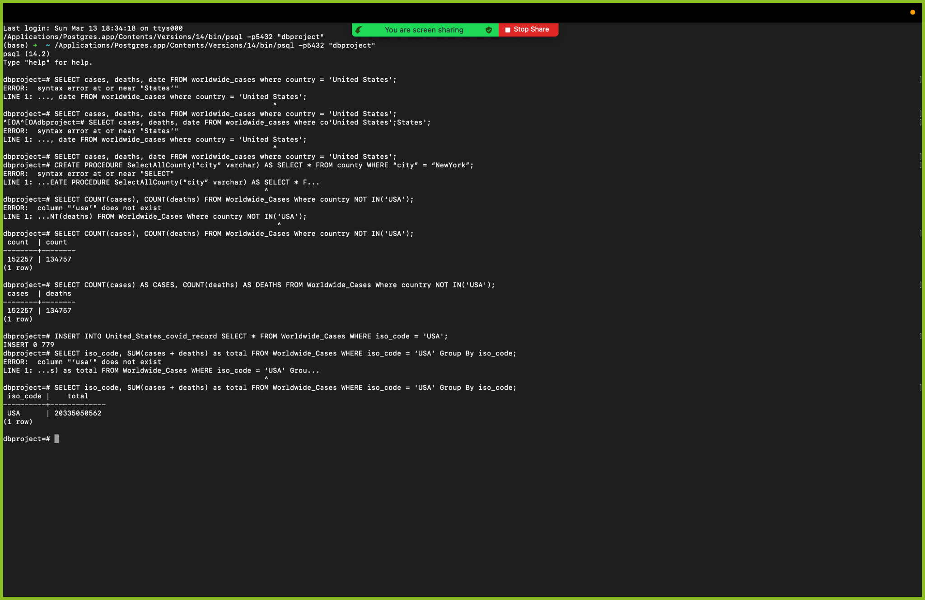

1. Write a query to obtain highest cases and deaths in the world

**SELECT MAX(cases) as cases, MAX(deaths) as deaths FROM Worldwide_Cases**

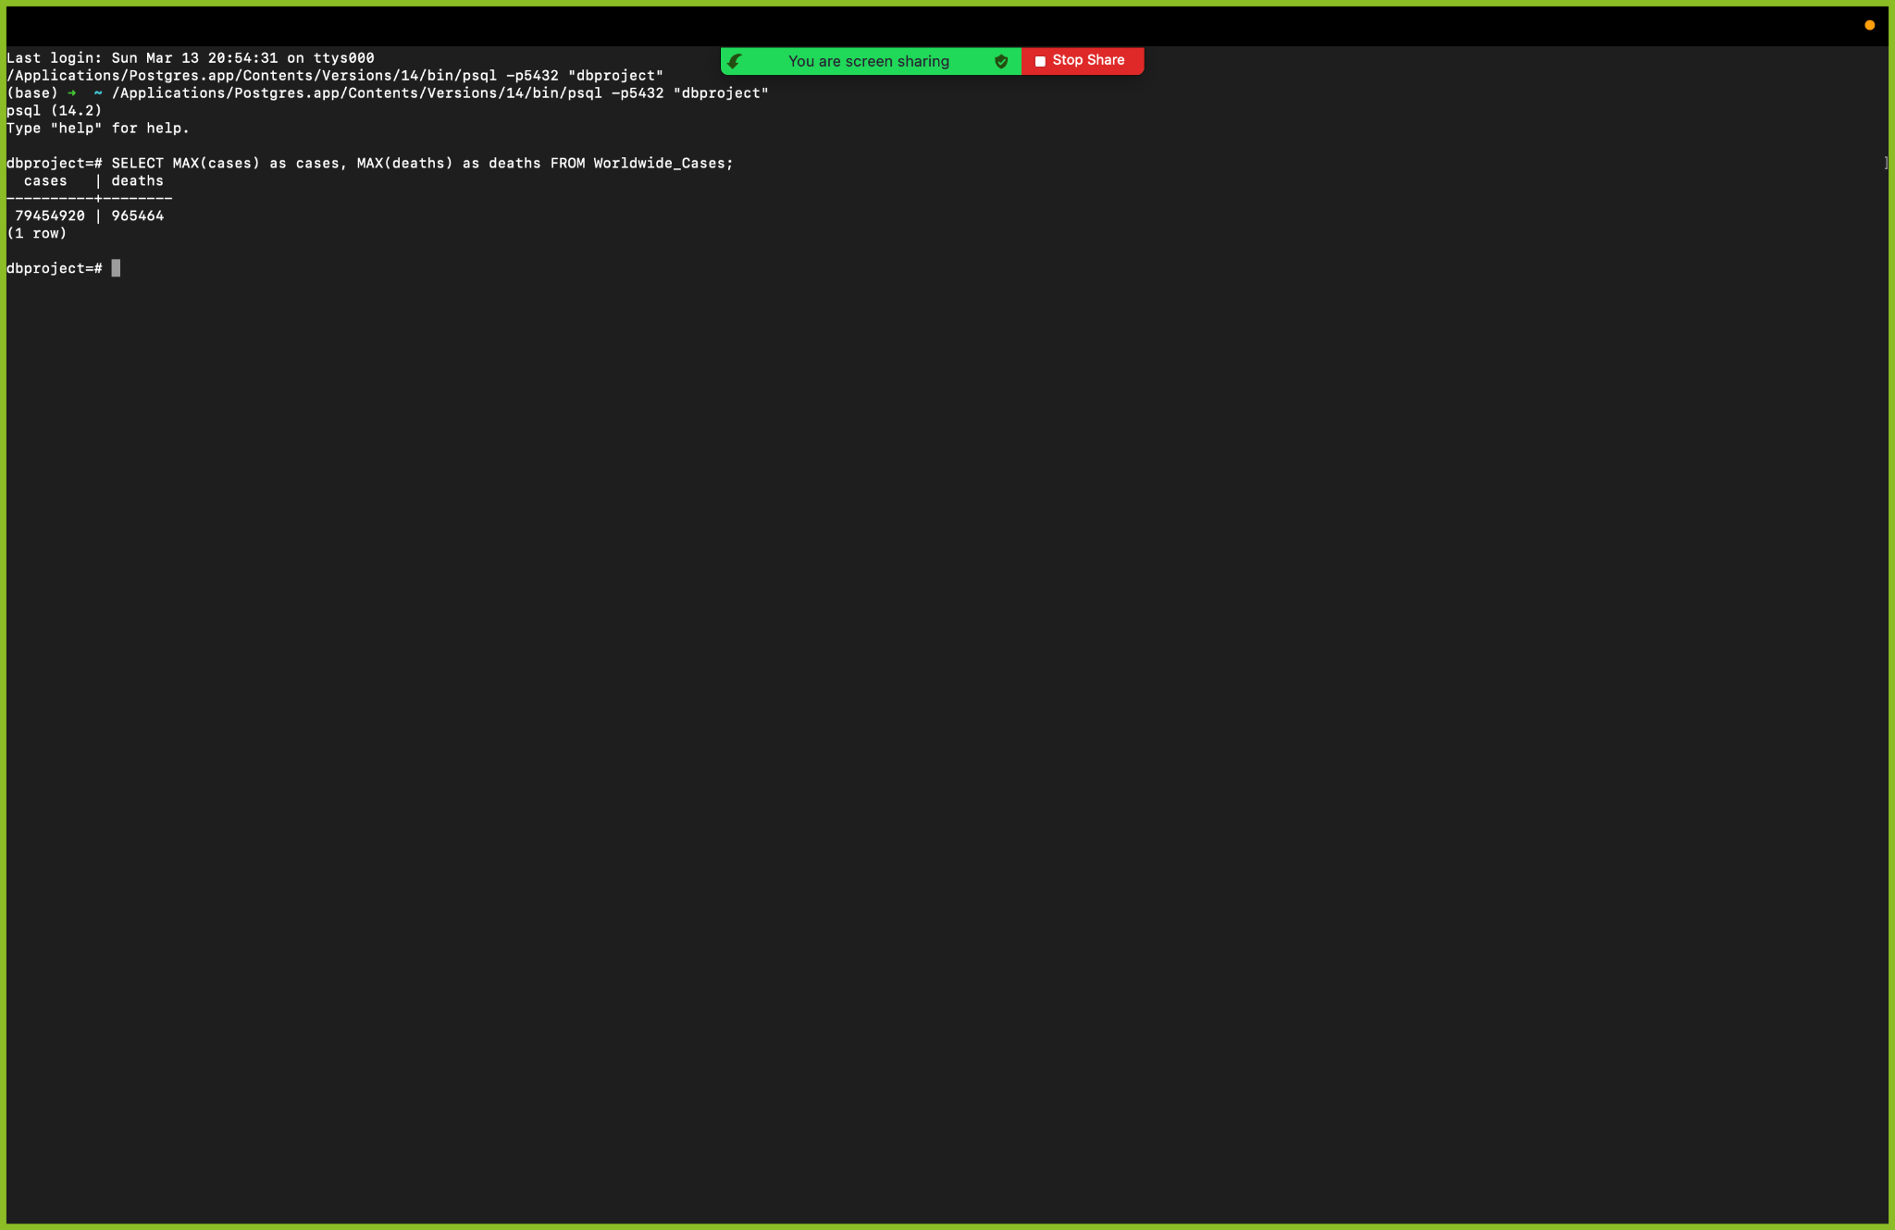

1. Write a query that returns count of cities in each state of United States

**SELECT state, count(city) FROM US_States Group By state;**

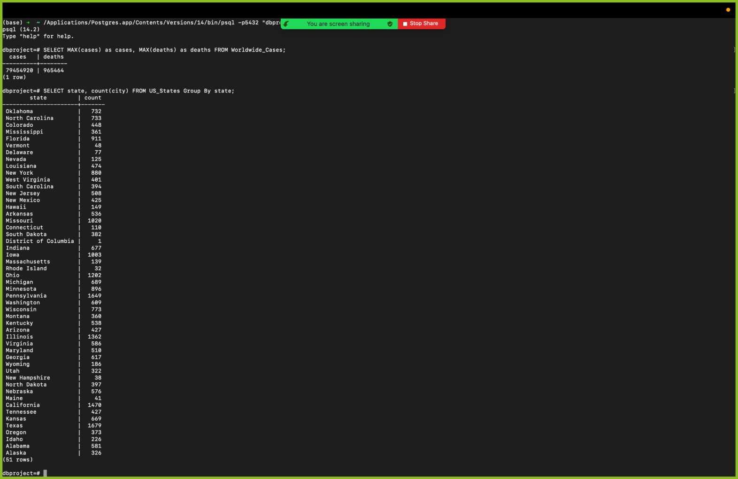

1. Write a query that returns colleges names where cases in 2020 is greater than 100 and starts with letter “U”

**SELECT clg_name FROM US_College_Cases WHERE cases2020 > 100 and clg_name LIKE ‘U%’;**

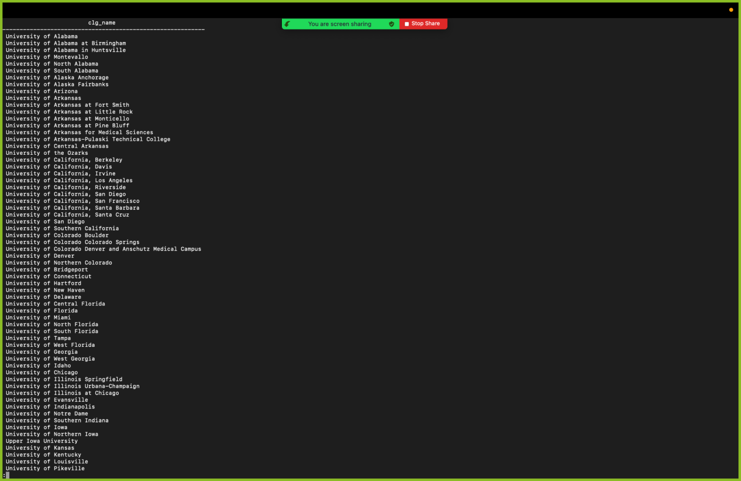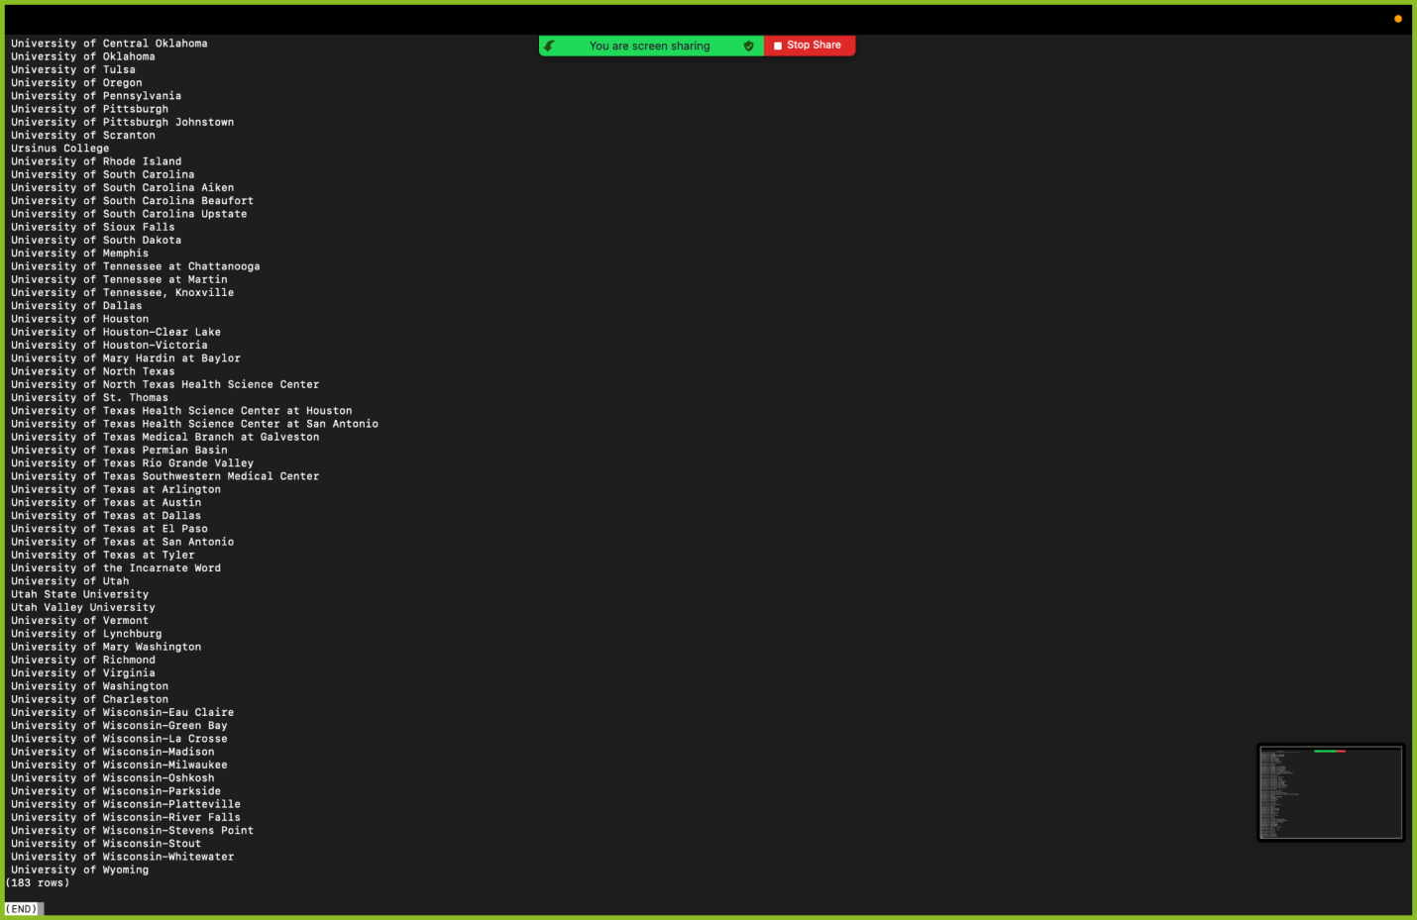

1. Write a query to return college id, name and total number of cases in 2020 and 2021

**SELECT clg_ID, clg_name, cases2020+cases2021 as total FROM US_College_Cases;**

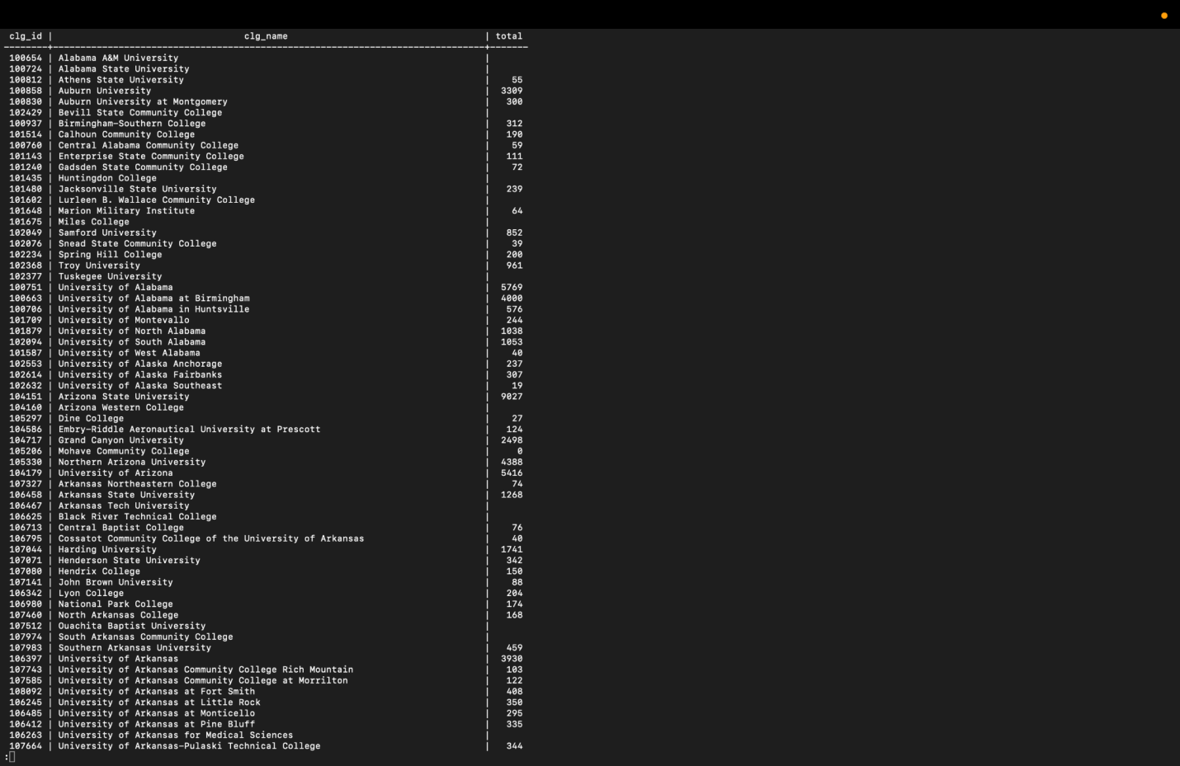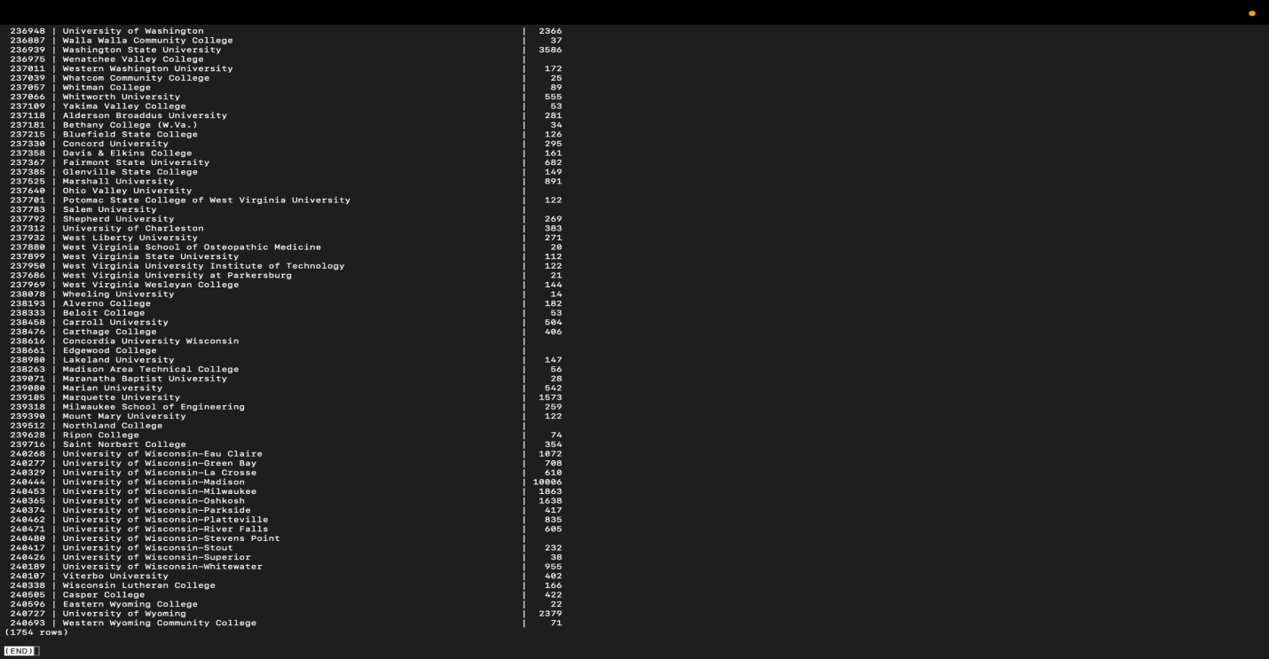

1. Write a query that returns city and state code of college with highest number of cases

**SELECT UR.city, UR.state_code FROM USCollegeRel as UR JOIN US_College_Cases as UC ON UR.clg_ID = UC.clg_ID WHERE cases2020 = (SELECT max(cases2020) FROM US_College_Cases);**

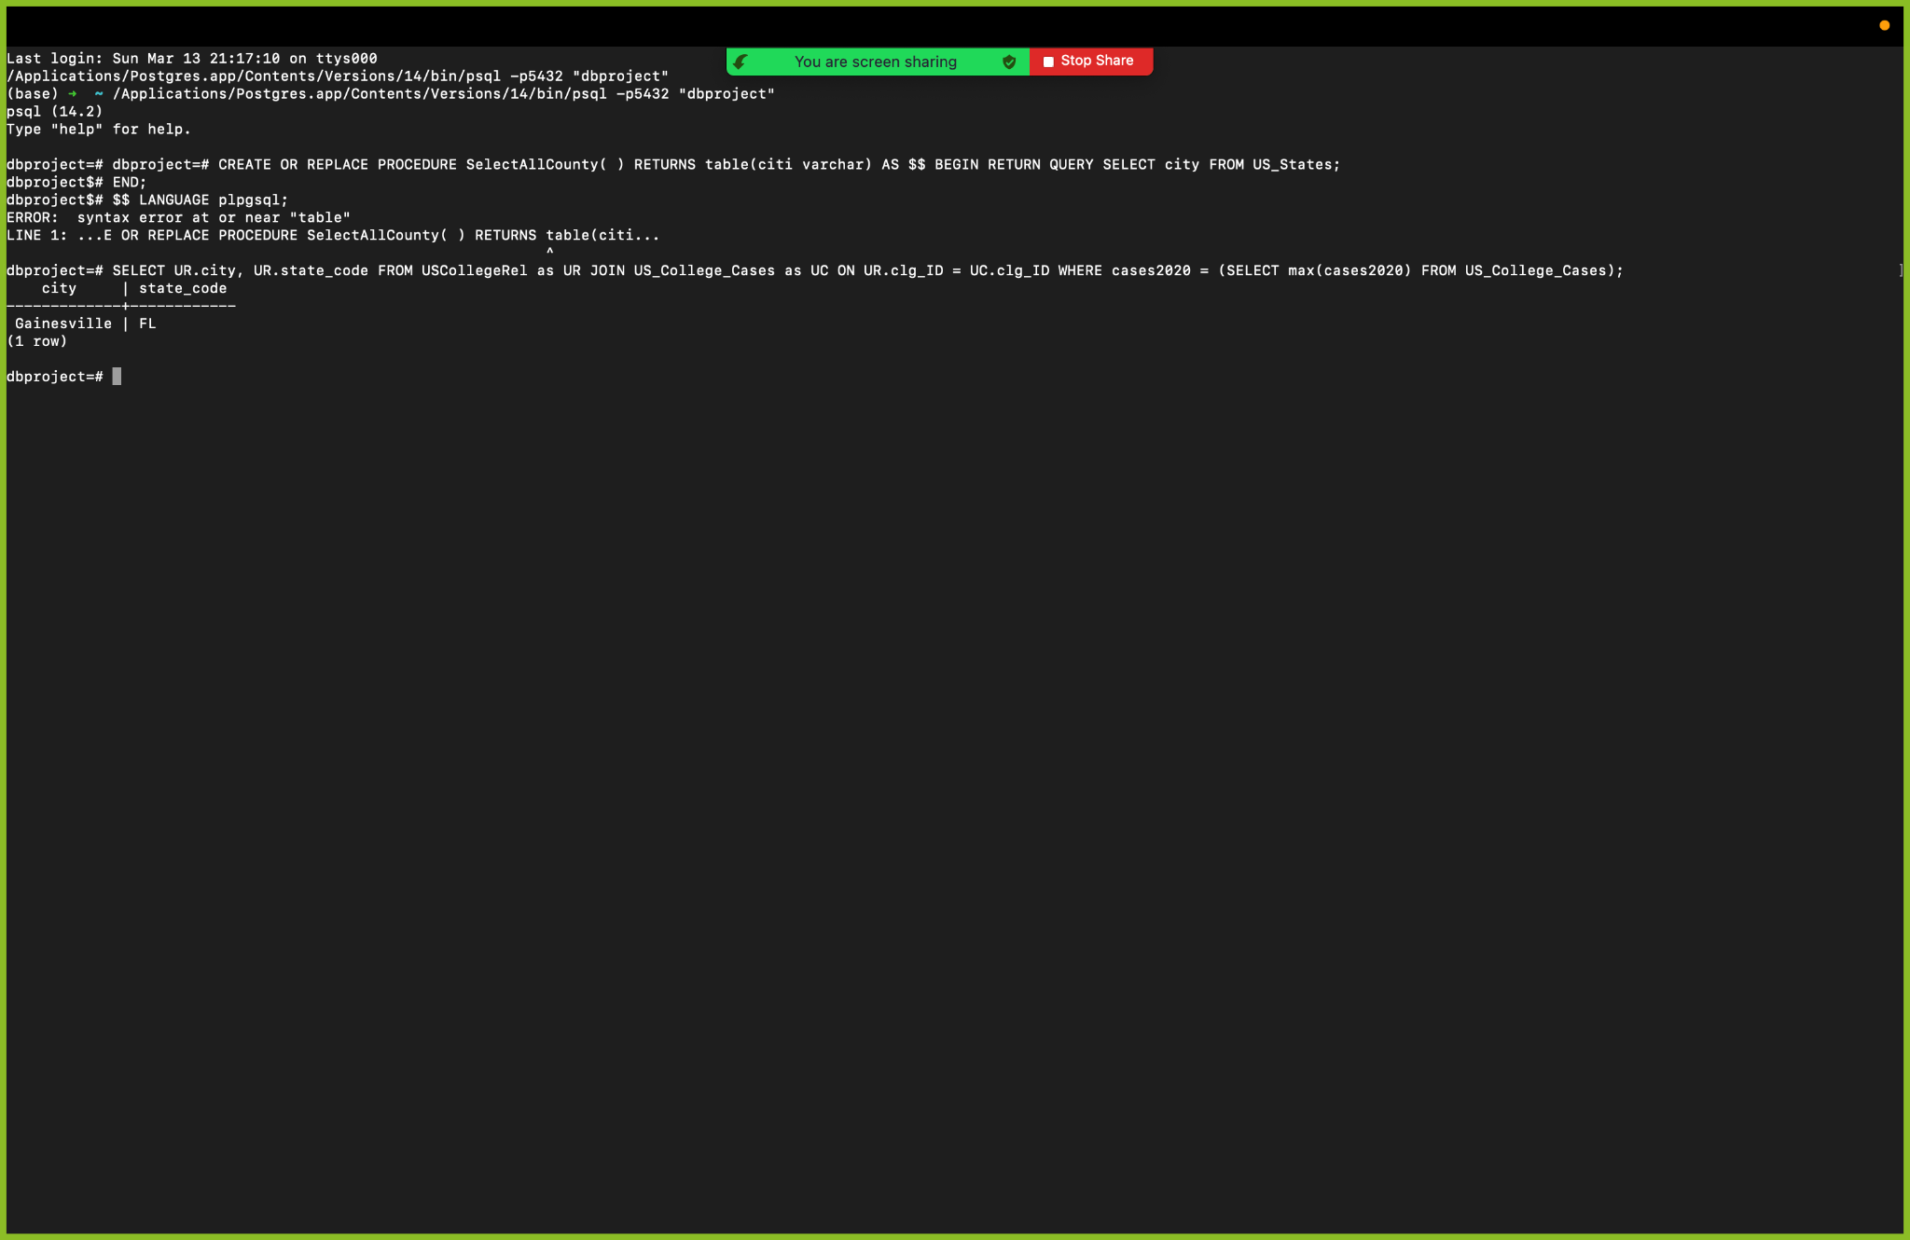

1. Write a query that returns iso code, country, cases and deaths worldwide from 05-2020 to 01-2021

**SELECT iso_code, cases, deaths FROM Worldwide_Cases WHERE date BETWEEN ‘05-01-2020’ AND ‘01-01-2021’;**

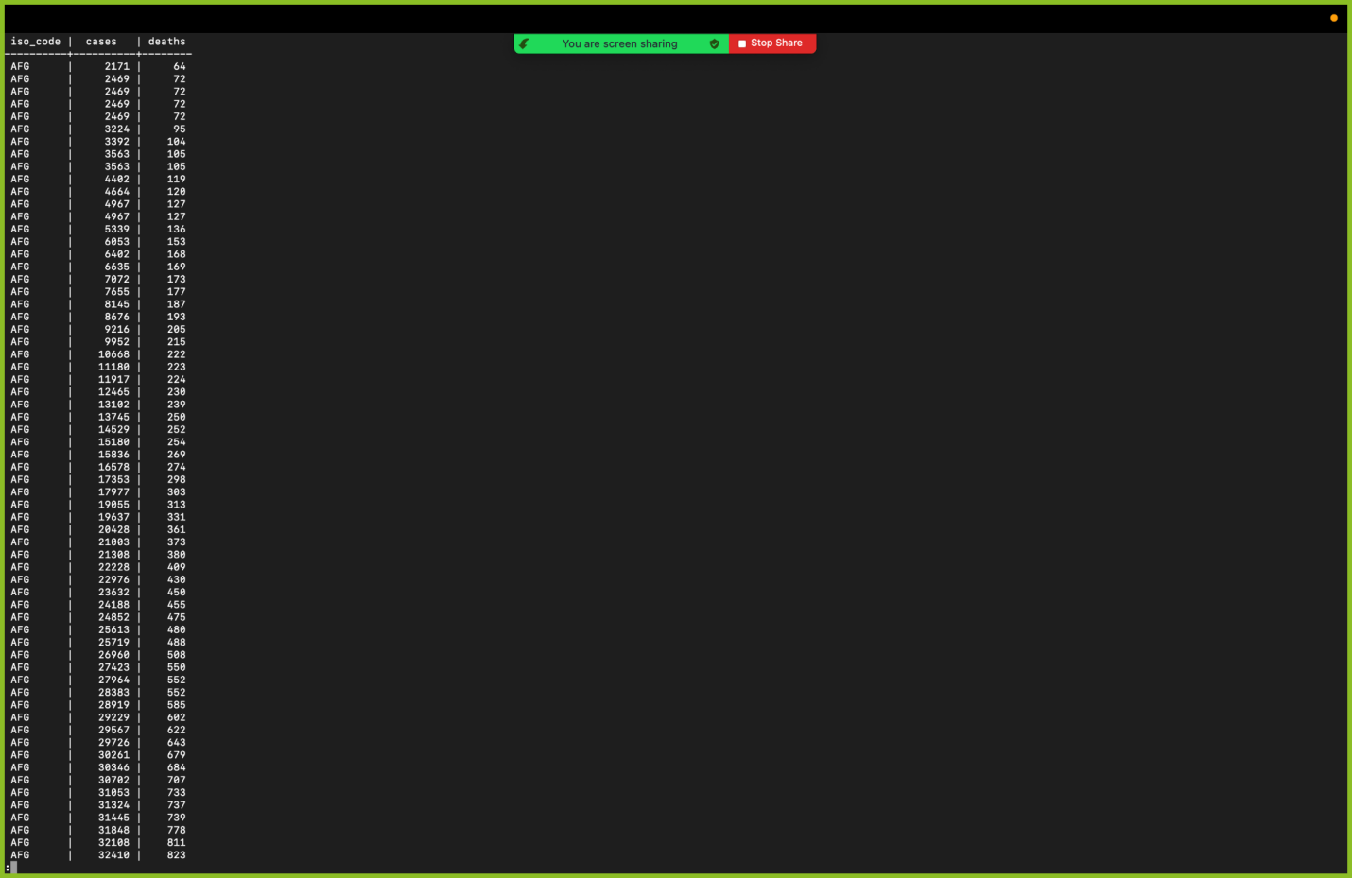

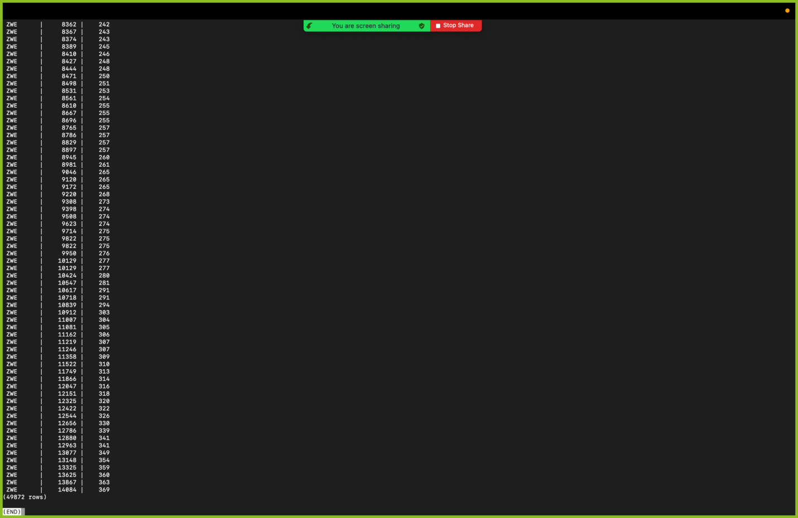

1. Write a query that returns college id and college name that have more than one cases in 2020; include college id and name that does not have any cases in 2020

**SELECT clg_ID, clg_name FROM US_College_Cases WHERE cases2020 > 1 AND cases2020 = 0;**

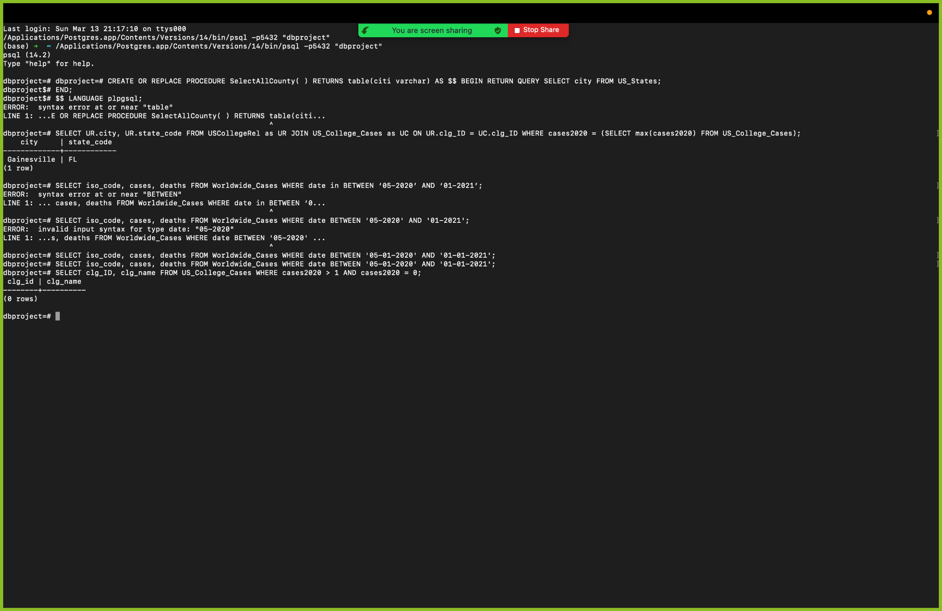

1. When inserting new college covid cases in 2021, write a query to check the college Id exists in college reference

**SELECT clg_ID from US_College_Cases WHERE cases2021 IN (SELECT clg_ID FROM US_College_Cases);**

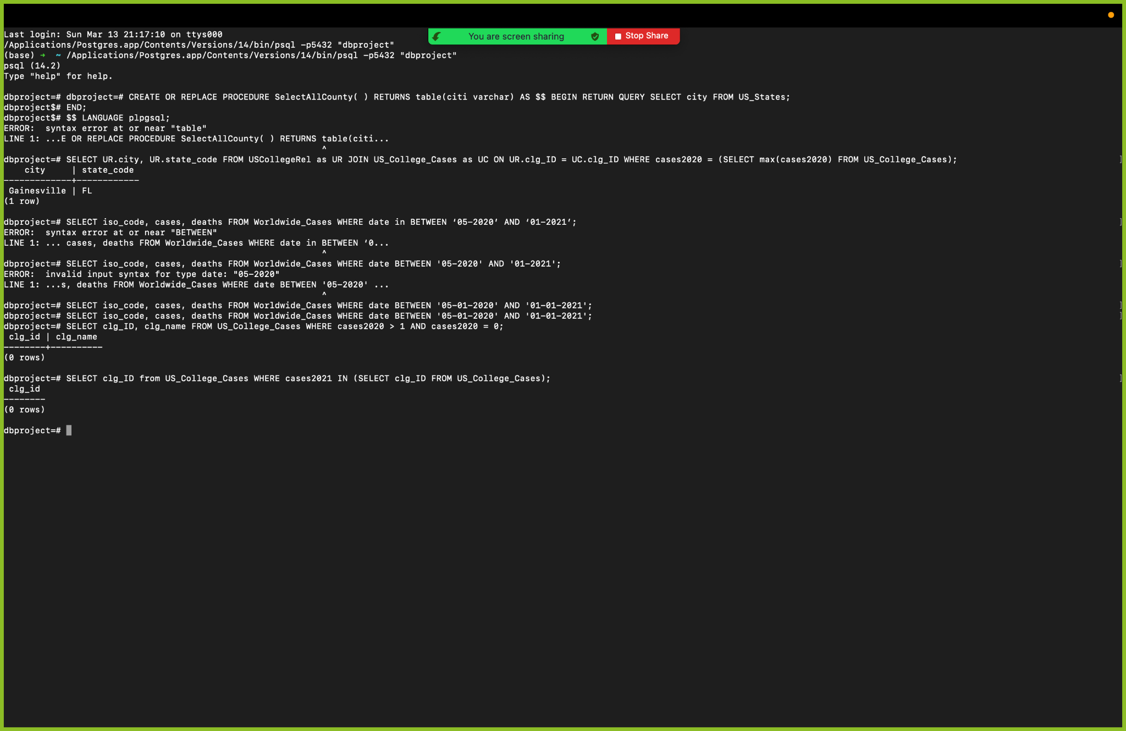

1. A view highCovid giving the college id, name and total number of cases in 2020 and 2021 with total cases is greater than 500

**CREATE VIEW highCovid AS SELECT clg_ID, SUM(cases2020+cases2021) as total FROM US_College_Cases WHERE cases2020 > 500 GROUP BY clg_ID;**

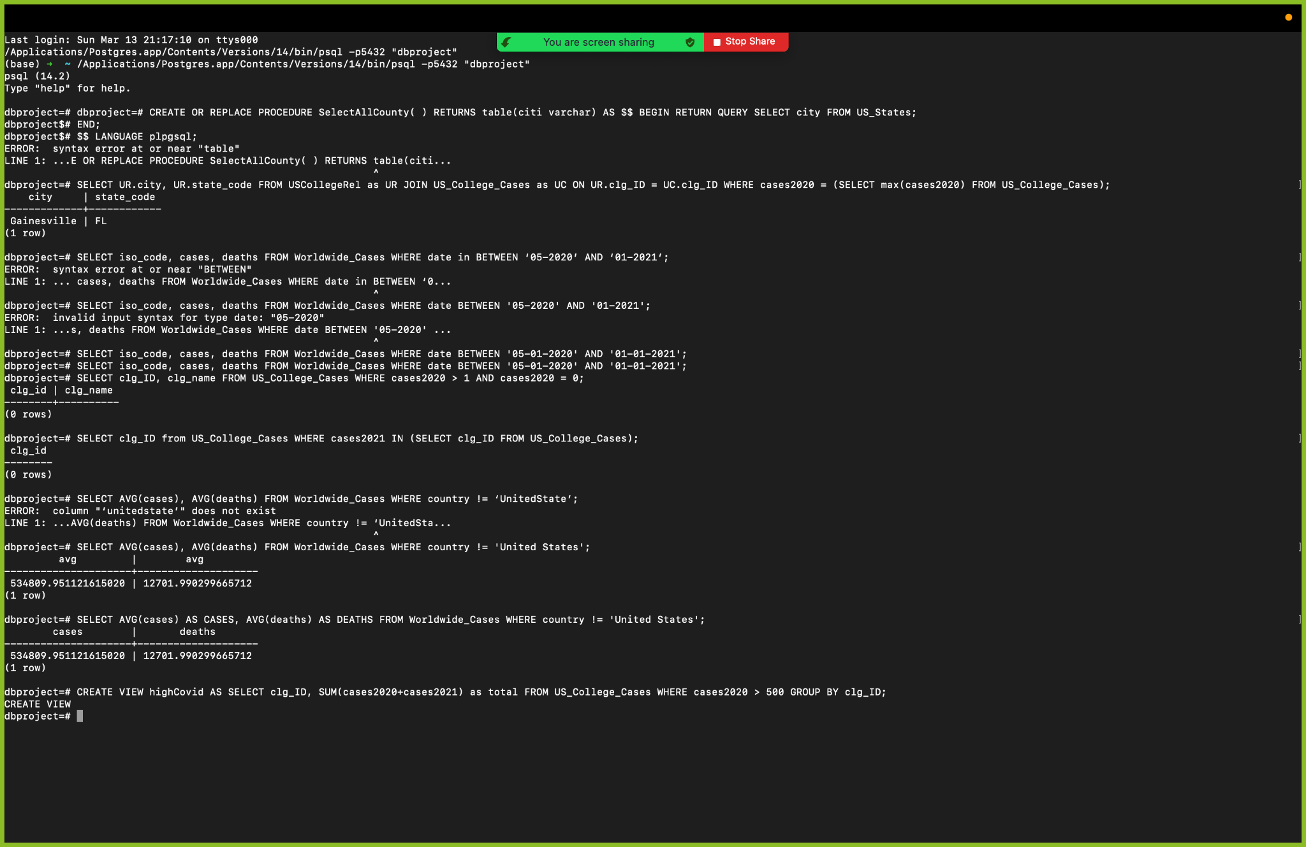

1. Create an index that is named on the city names in the US_states table.

**CREATE INDEX city_names ON US_state (city);**

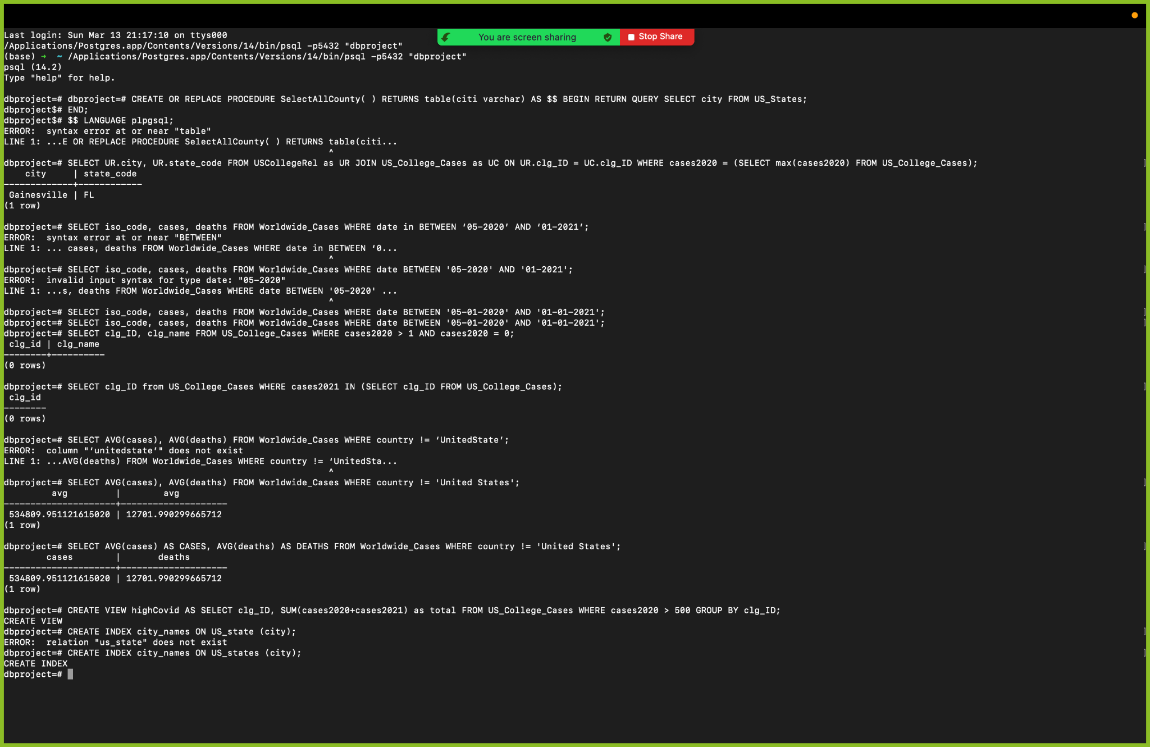

1. Create a function that selects county from a particular city from the US_states table

**CREATE OR REPLACE FUNCTION SelectAllCounty( ) RETURNS table(citi varchar) AS $$ BEGIN RETURN QUERY SELECT city FROM US_States;**

**END;**

**$$ LANGUAGE plpgsql;**

**SELECT citi from SelectAllCounty();**

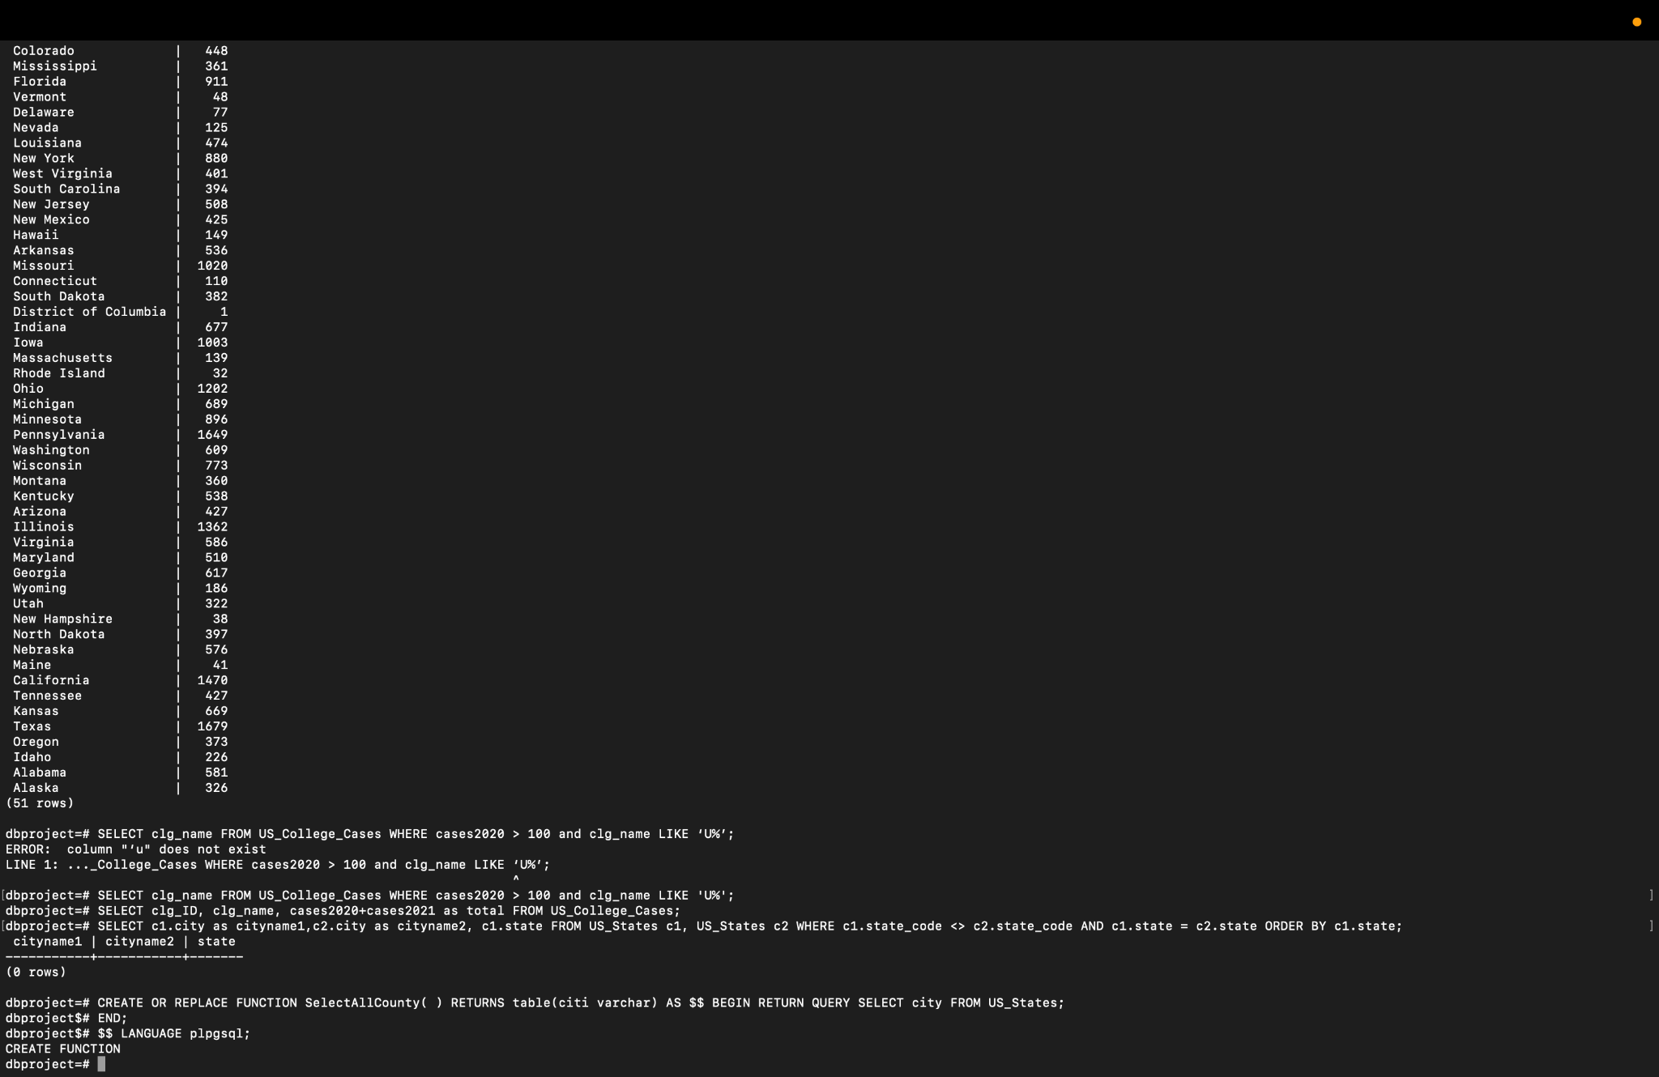

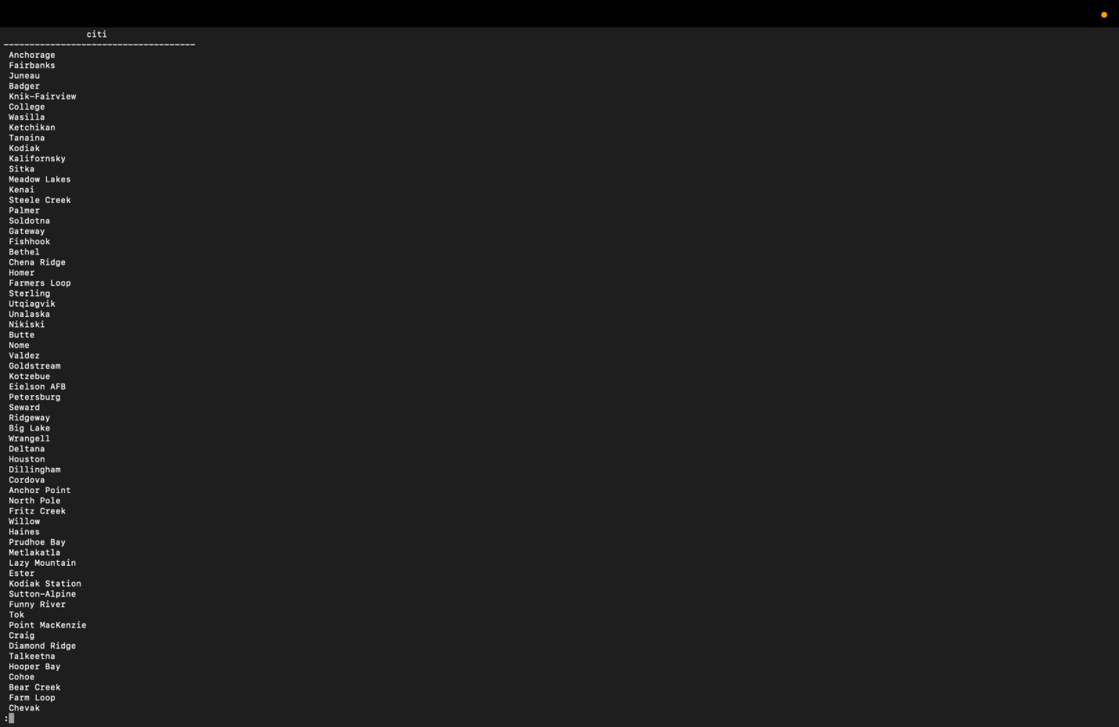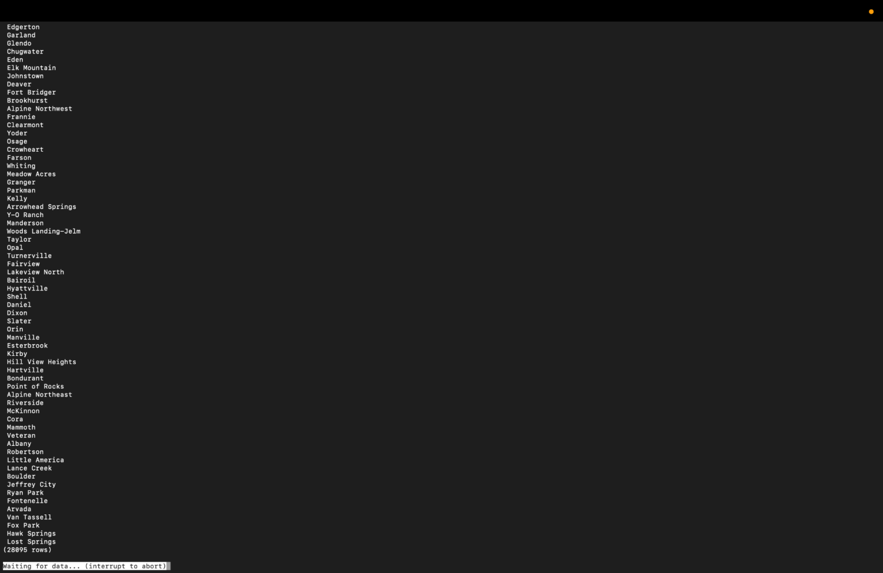

1. The table that contains clg_id that have been affected with covid in 2021

**CREATE TABLE college_cases (clg_ID int, clg_name VARCHAR(30), CHECK (cases2021 >100);**

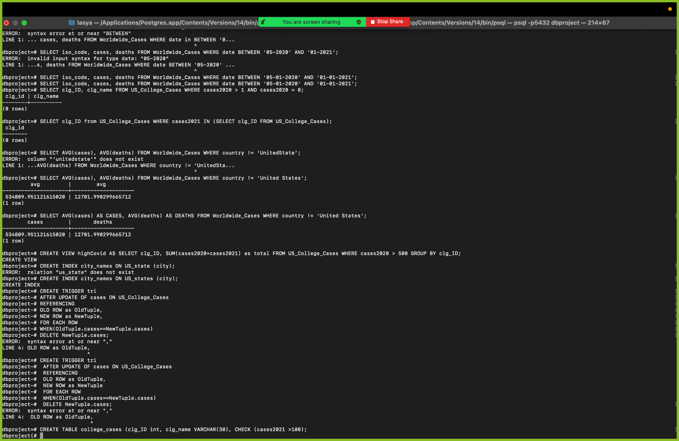

1. Write a query that matches city names that are from the same state.

**SELECT c1.city as cityname1,c2.city as cityname2, c1.state FROM US_States c1, US_States c2 WHERE c1.state_code <> c2.state_code AND c1.state = c2.state ORDER BY c1.state;**

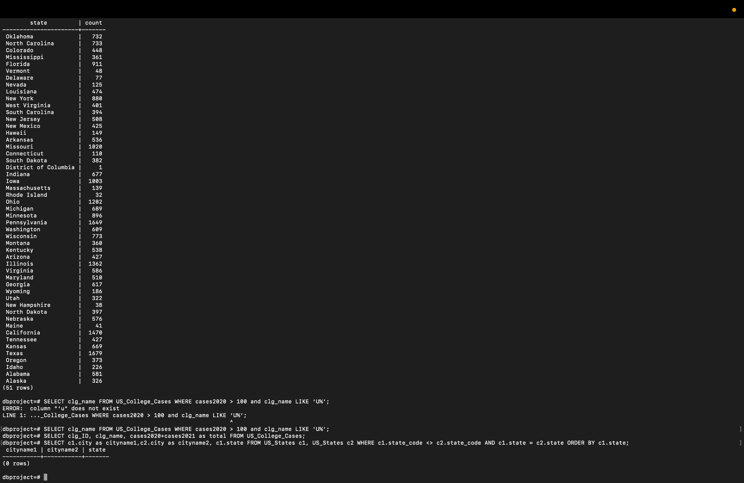

1. When inserting a new case in 2020 or 2021 of any college make sure that the college id did not appeared previously

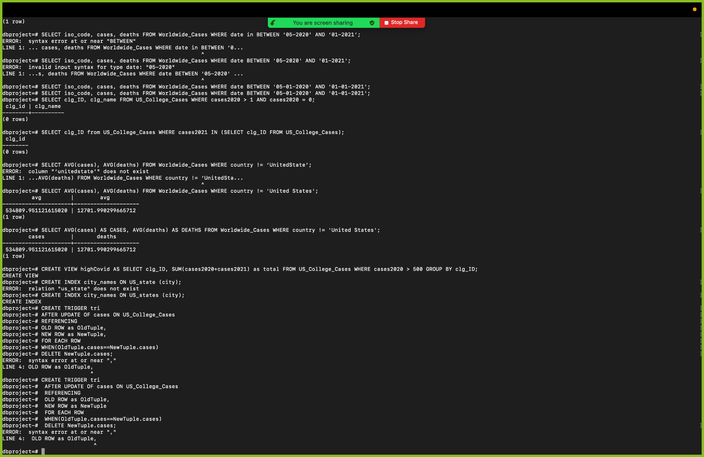

1. Update the first city with a new city and state.

**UPDATE US_States SET city = ‘Anchorage’ , state = ‘Alaska’ WHERE state_code = ‘AK’;**

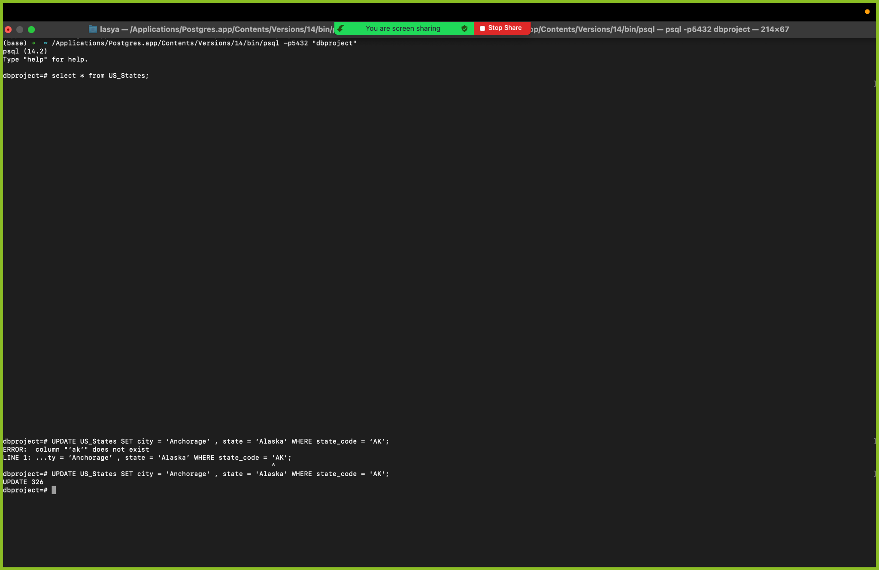

[pendyala@pdx.edu](mailto:Pendyala@pdx.edu)

[thoutam@pdx.edu](mailto:thoutam@pdx.edu)